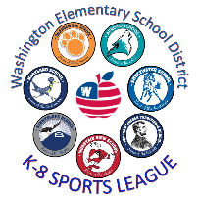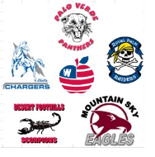**WESD Athletics Values Statement**

WESD schools are committed to maintaining and improving high standards of conduct during athletic competitions. Please keep in mind that this is elementary and middle school competition, and therefore, is still considered a developmental setting, with the focus being to learn the fundamentals and personal conduct associated with each sport.

All spectators, coaches, and players, no matter their personal feelings of loyalty, should reflect an attitude of sportsmanship. To that effect, we ask everyone to support the best these athletes have to offer, and not to provide distractions or disruptions, with the intent to influence in a negative way, the efforts of these developing athletes.

**WESD Spectators’ Code of** **Behavior**

* I will encourage good sportsmanship by demonstrating positive support for all players, coaches, and officials at every game, practice, or event.
* I understand that if I have an issue, I must speak with the coach in a private, appropriate, and timely manner and that I am not to speak to officials about the game.
* I will place the emotional and physical well-being of my child and team ahead of the personal desire to win.
* I will be supportive of my child, the team, and the coaching staff throughout the entire season by offering encouragement, displaying a positive attitude, and using language appropriate for the school
* setting.
* I will remember that the game is for the students – not for adults.
* I will, through my own actions, teach my student how to treat other players, coaches, fans, and officials with respect regardless of the other person’s ability.
* I will do my very best to make youth sports fun for my athlete and will help my athlete to enjoy the season.

Guardian Name(s):___________________________________________________________________

GuardianSignature(s):________________________________________________________________Date:____________

**Student Code of Ethical Behavior**

Welcome to WESD sports! We are honored that you trust us with your student athlete. In order to make the season the best it can be, we are asking you and your student to agree to the following Code of Ethical Behavior.

Student Code of Ethical Behavior

* I understand that as a student athlete, I am a role model and held to the highest standard.
* I will not act in any way that would cause me to receive any type of discipline report/action.
* I understand that I will not be a part of any actions that disrespect the team, our school, the school district, or m.
* I understand that consequences of breaking this agreement will be suspension and/or removal from the team.

Student Print Name:__________________________

Student Sign Name:__________________________ Date:_______________

