**Starting Day**

In order to assure that you have a successful day, arrive at the scheduled arrival time to prepare for the day. A substitute teacher must check in with the school office upon arrival. A substitute teacher needs to be become familiar with class information to carry out the plans of the day. This pertinent information includes:

* Lesson plans
* Daily schedule
* Discipline procedures
* Routine Procedures
* Emergency Procedures
* Students with special needs
* Students with special classes
* Seating chart
* Locating necessary materials

At the beginning of the day let the students know you are pleased to be in their classroom and assure them you expect them to behave. When subbing observe this motto: BE FAIR, BE FRIENDLY, BUT BE FIRM. Students need to know you are there to teach and they are there to learn. Request help if you need it! Do not hesitate to ask grade level teachers or the principal for assistance.

**Online Classroom Resources**

Need a Lesson Plan? An activity to fill a few minutes at the end of the day? These resources are available for you Online in the Centricity intranet! To access the site:

1. Start at wesdschools.org
2. Click **Sign In,** at the top right of the page
3. Your user name is your employee ID number/Pin. Your default password is Washington6, which can be changed to something personal after the first use.
4. 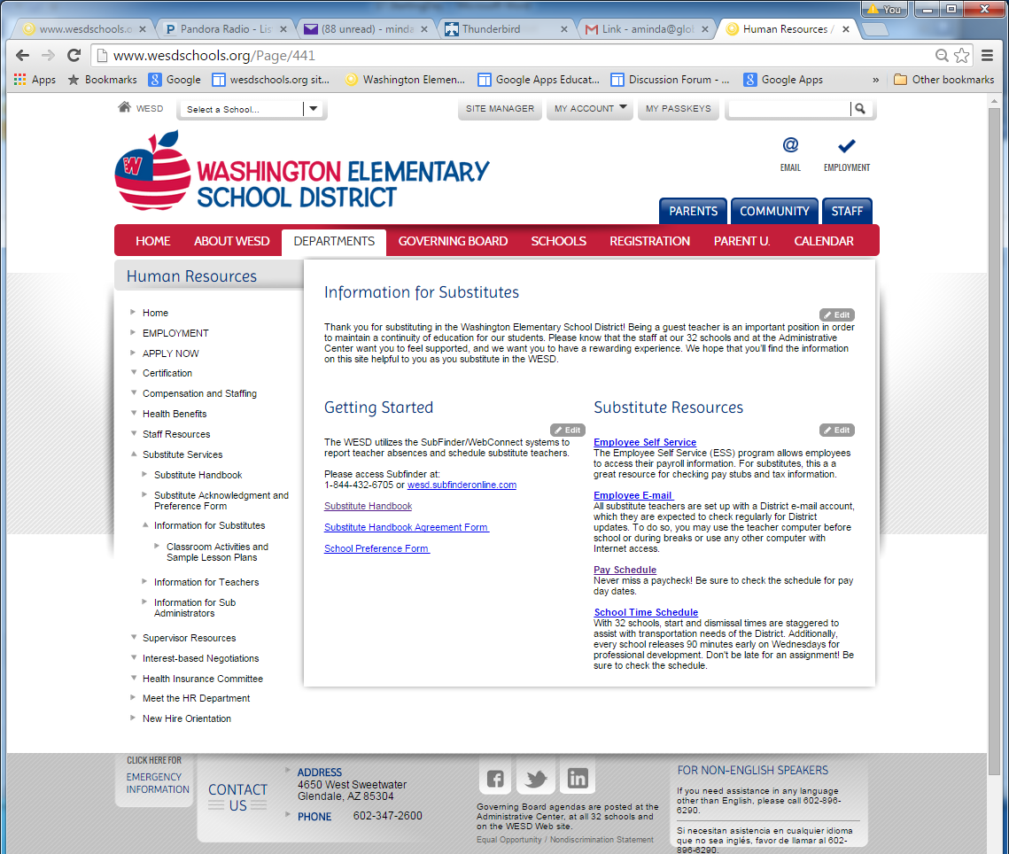Click **Departments**
5. Click **Human Resources**

Now that you are logged in, you will see a new menu option along the left sidebar!

1. Click **Information for Substitutes**
2. Click **Classroom Activites and Lesson Plans**. Enjoy!